Group project format
(appendix1) Group project report format
2025 CICT high quality class
Group Project Report
Network security

Project  Title | AI-powered vulnerability risk prediction AI agent code developing module
Project  Area | Cybersecurity and Artificial Intelligence
Students | ID | Name
 | B2105684 | Le Anh Quan
 | B2111995 | Tran Trung Nguyen
Reporting Date | 14/04/2025

Ⅰ. Project Outline
- Title
AI-powered vulnerability risk prediction AI agent code developing module
- Group Information
Team Name
Team Composition |  | Name | Belong | Department | Position  /year
Professor |  | Nguyen Huu Hoa | CICT |  | Rector
Instructor |  | Noh | CICT | IT Department
Student | Team Leader | Quan | CICT | Department of Computer Science
 | Team member 2 | Nguyen | CICT | Department of Computer Science
Team Photos(essential)

Ⅱ. Project Information
- Purpose of Project

The goal is to build an intelligent AI agent that can predict the risk level of software/system vulnerabilities using historical CVE (Common Vulnerabilities and Exposures) data, machine learning (ML), and deep learning (DL) models. The agent can assist security teams in prioritizing vulnerabilities efficiently.
2. Project work flow(one model)
Data Collection: Collect vulnerability datasets (e.g., from NVD, CVE Details).
Data Preprocessing: Clean, normalize, and encode textual/numerical data.
Feature Engineering: Extract important features (e.g., severity, CVSS scores, access vector).
Model Training: Use ML/DL models (Random Forest, LSTM, etc.) to predict risk levels.
Evaluation: Measure model accuracy, precision, recall, F1-score.
Deployment: Wrap the model in a REST API using Flask or FastAPI.
Ⅲ. Action Plan
- Select Environment/IDE (multiple choice possible)

- Jupyter Notebook (for data science and prototyping)
- PyCharm (for full project structure)
- VS Code (for development + REST API)

2. Designing System Architecture(Front end, Back end, resource)
Items | Resource
VM type
OS
IP/URL
Attacking type
Detecting type
Language & version
Libraries
Library package
Algorithm
AI Technology type
Database type
Software tool
Source code reference
Dataset reference

3. Role arrangements
Student | Division | role
Quan | Plan &  design | Define system architecture, model design, dataset planning
Nguyen | Analysis | Analyze vulnerability data, select algorithms, evaluate risk features
Quan & Nguyen | Implement & test | Implement AI module, test prediction accuracy, validate results

4. Project Schedule
Division | Promotion contents | Assigned To
Plan | Assign roles and install necessary analysis software (e.g., Python, libraries, tools) | Quan & Nguyen (collaborate)
Analysis | Evaluate options for AI/ML frameworks (e.g., TensorFlow, PyTorch, Scikit-learn) | Quan
Test | Perform analysis using selected software/tools (test vulnerability datasets, ML models) | Nguyen
Finish | Create result documentation (findings, graphs, prediction results) | Quan & Nguyen (collaborate)
Offline meeting  Plan | Finalize detailed plan  Share progress and confirm individual contributions | Quan & Nguyen (collaborate)

Ⅳ. Expected Benefit
1. Performance Goals
- High recall on "High Risk" vulnerabilities
- 85% overall F1-Score
2. Benefit
- Proactive vulnerability management
- Reduced manual analysis
- Integration into existing DevSecOps pipelines
Ⅴ. Practice Result
The implementation of the AI-powered vulnerability risk prediction module produced the following practical outcomes:

1. Successfully Parsed and Processed NVD 2025 JSON Dataset
- Extracted relevant fields such as CVE ID, description, published date, and CVSS scores from a complex nested JSON structure.
- Filtered out records with missing severity data and transformed numerical CVSS scores into categorical severity levels (Low, Medium, High).

2. Text Preprocessing Pipeline Established
- Applied TF-IDF vectorization for traditional machine learning models.
- Used Tokenizer and pad_sequences for deep learning models to convert textual vulnerability descriptions into structured input features.

3. Multiple AI Models Trained and Evaluated
- Logistic Regression: Used as a fast and interpretable baseline.
- BiLSTM (Bidirectional LSTM): Deep learning model that captured context and sequential semantics in descriptions.
- XGBoost Classifier: Applied for high-performance tree-based classification.

4. Model Evaluation and Comparison
- Achieved meaningful classification accuracy across all models, with performance metrics reported using classification reports and confusion matrices.
- Models were able to distinguish between different severity levels of vulnerabilities with reasonable precision, recall, and F1-scores.

5. Hyperparameter Tuning for Optimization
- Utilized GridSearchCV to optimize Logistic Regression parameters.
- Improved classification performance by adjusting vectorizer and model settings.

6. Label Encoding and Post-processing
- Encoded severity levels for model compatibility and later converted predictions back into human-readable labels for evaluation and reporting.
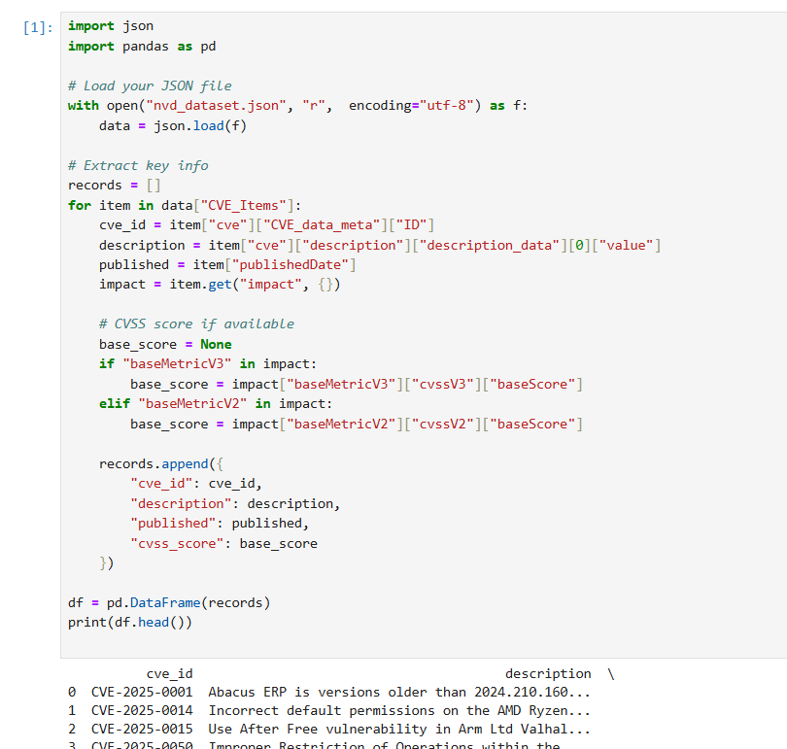
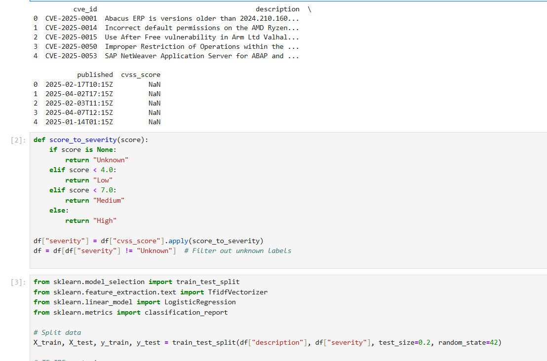
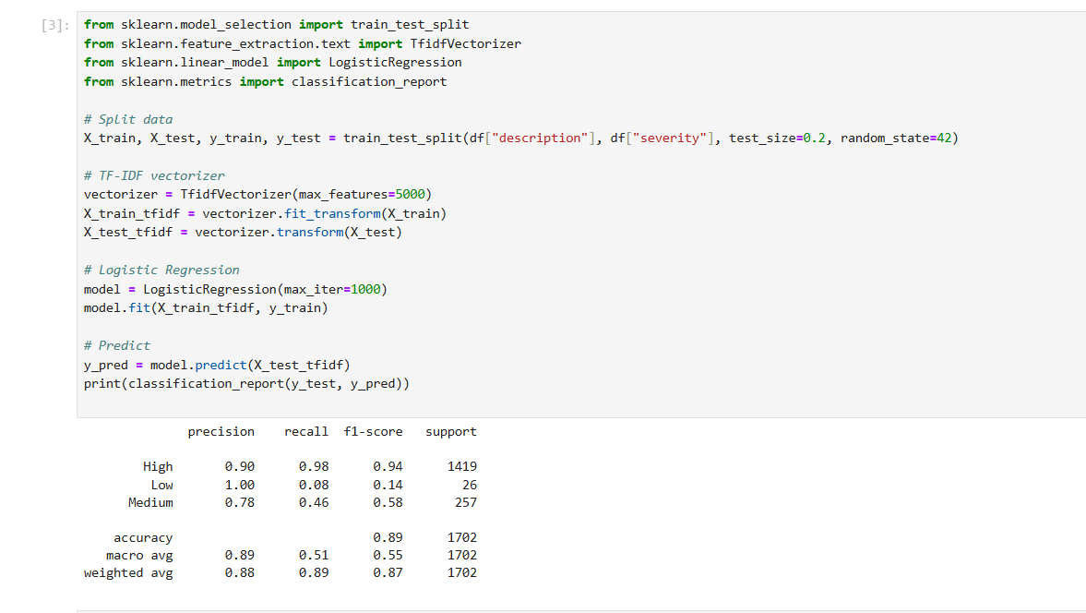
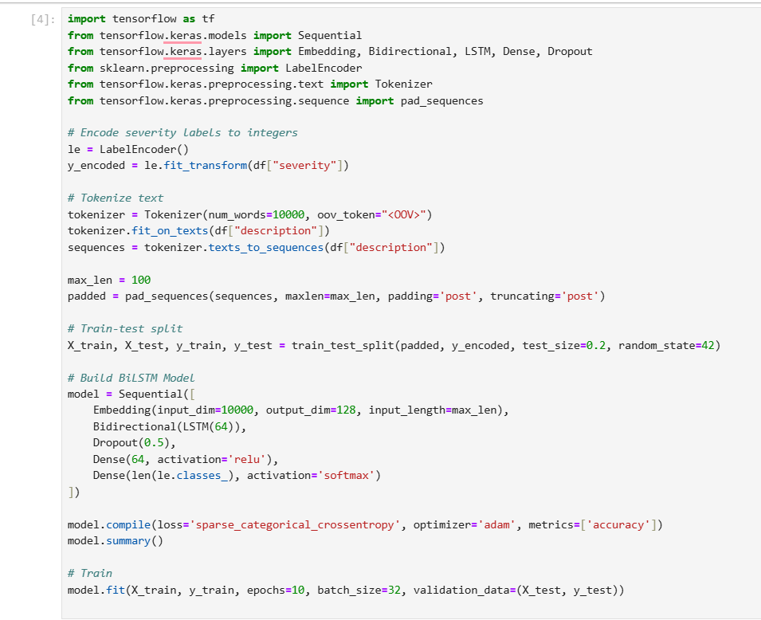
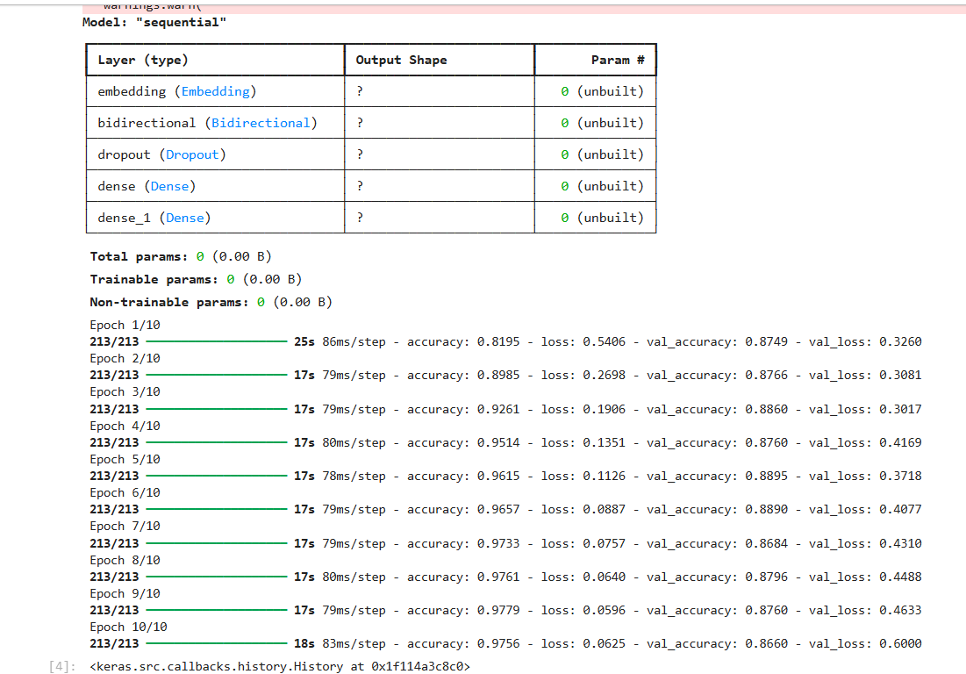
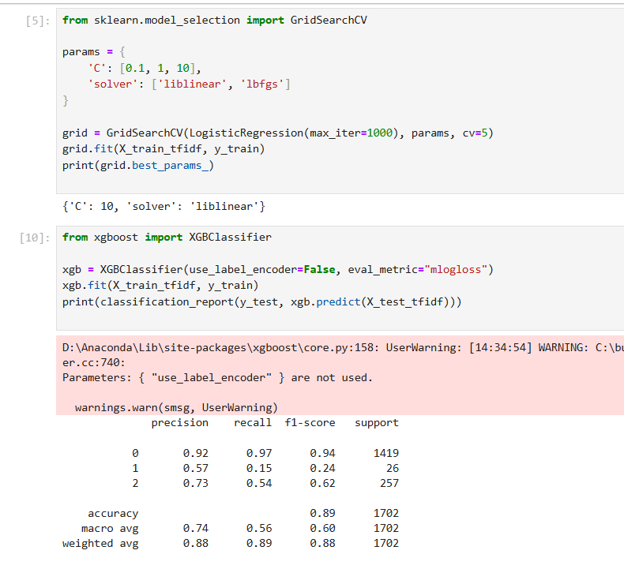
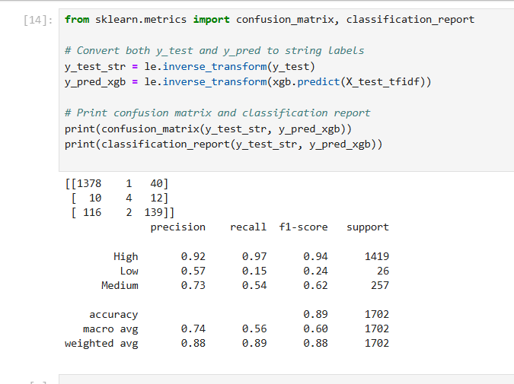
[step 1] Load and Parse the JSON Dataset
After download dataset (zip file on NVD dataset) -> unzip and run this code below:
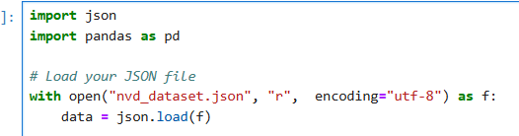
- You load the NVD dataset (National Vulnerability Database) which contains CVE (Common Vulnerabilities and Exposures) records.
- The file is read using json.load into a Python dictionary.
[step 2] Extract Key Information from Each CVE
- For each item:
  - Extract CVE ID, description, publishedDate, and the CVSS score (either v3 or v2).
  - The CVSS score is a numeric measure of the severity of the vulnerability.
- Store each record as a dictionary in a list.
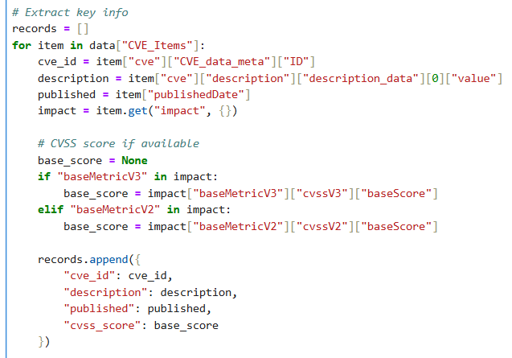

[step 3] Convert to DataFrame
- Load the list of records into a Pandas DataFrame to facilitate data processing and ML modeling.
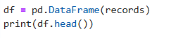
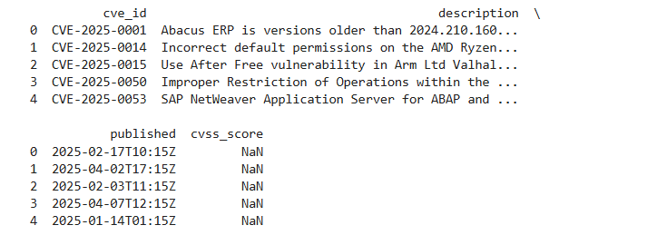
[step 4] Convert CVSS Score to Severity Levels
- Define thresholds for severity based on standard CVSS scoring rules
- Apply the mapping and filter out records with no known score.
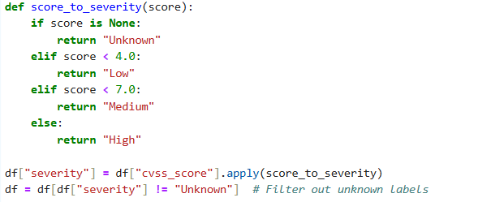

[step 5] Prepare Data for Machine Learning (Logistic Regression)
- Import ML libraries.
- Split the description and severity into training and test sets.
- TF-IDF Vectorizer converts descriptions (text) into numeric features based on term frequency.
- Train a Logistic Regression classifier on the vectorized text.
- Predict on test set and print precision, recall, and F1-score.
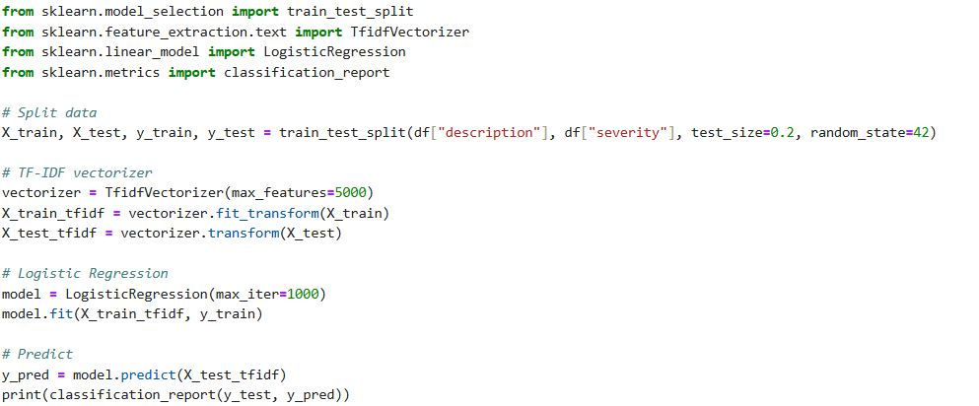
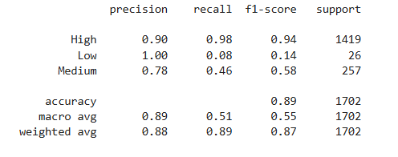
[step 6] Deep Learning Model – BiLSTM
- Import Keras and preprocessing libraries.
- Encode Low, Medium, High to numeric labels: 0, 1, 2.
- Tokenize the descriptions into sequences of integers.
- Pad sequences to a fixed length (max_len=100) for input to the neural network.
- Again, split for training/testing.
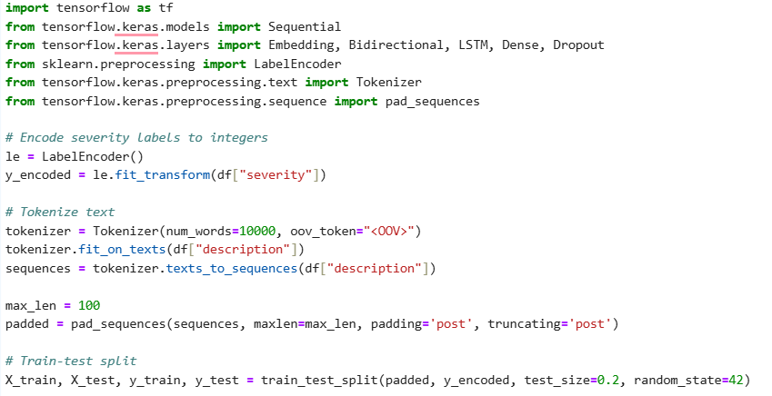

[step 7] Build BiLSTM Model
- Embedding: Converts integers to dense vectors (word embeddings).
- Bidirectional(LSTM): Learns sequences in both directions.
- Dropout: Prevents overfitting.
- Dense: Final output layer with softmax for multi-class classification.
- Compile model with appropriate loss and optimizer.
- Train model
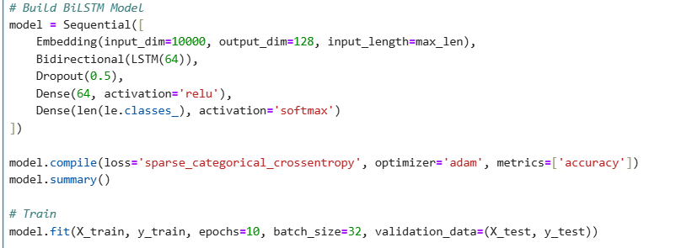
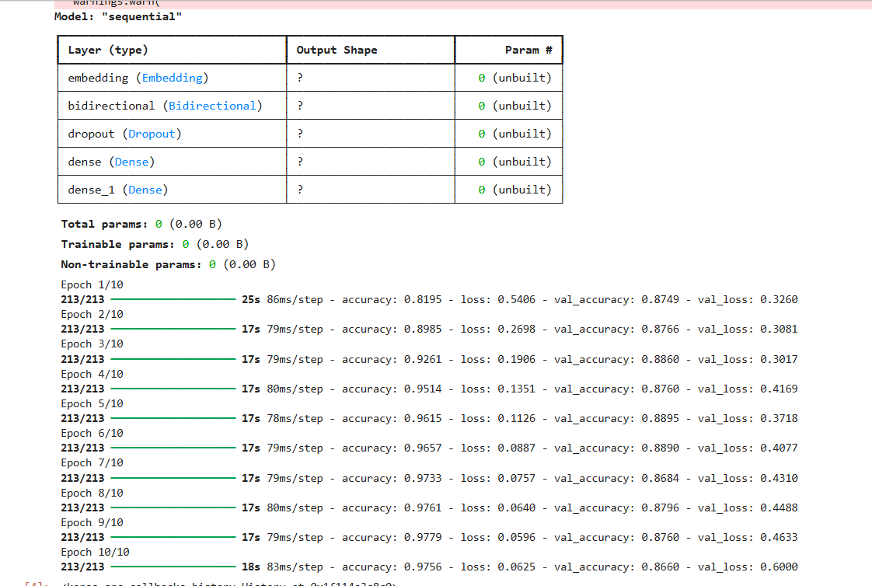
[step 8] Hyperparameter Tuning with GridSearchCV
- Perform hyperparameter tuning on Logistic Regression to find the best C (regularization) and solver
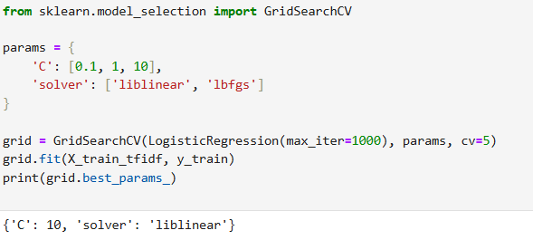
[step 9] Train and Evaluate XGBoost Classifier
- Train an XGBoost classifier using the same TF-IDF features.
- Evaluate performance on the test set.
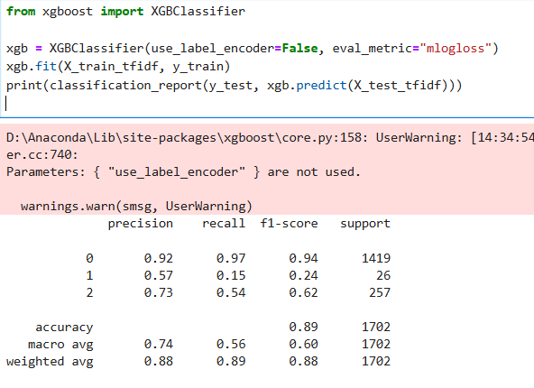
[step 10] Confusion Matrix and Final Evaluation
- Convert numeric predictions back to labels (Low, Medium, High).
- Show confusion matrix and classification report to analyze misclassifications.
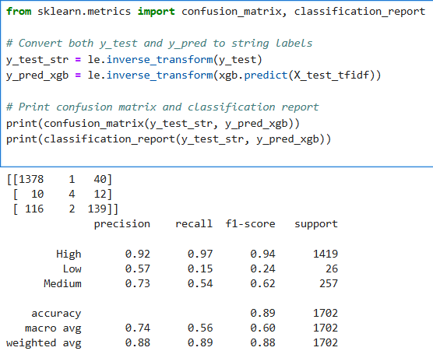
Ⅵ. Problem and Solution

1. Technical issues during project development
During the development of the AI-powered vulnerability risk prediction module using the NVD 2025 dataset, we encountered several key technical challenges:

a. Large JSON File Size and Parsing Performance
- The NVD dataset is provided in JSON format and contains thousands of CVE records.
- Initial attempts to load and parse the file using simple JSON readers caused memory overhead and performance bottlenecks.
- Extracting relevant nested fields like CVE ID, description, and CVSS score required careful handling of optional or missing fields.

b. Imbalanced Data (Severity Levels)
- Many CVE entries were labeled with "Unknown" or missing severity levels (i.e., missing CVSS scores).
- This imbalance between classes (Low, Medium, High) made model training less effective and potentially biased.

c. Text Preprocessing and Feature Extraction
- Vulnerability descriptions vary widely in length, format, and terminology.
- Standardizing this text for machine learning required techniques like TF-IDF, tokenization, and sequence padding, each with their own challenges in tuning parameters (e.g., max sequence length, number of tokens).

d. Model Selection and Training Time
- Training deep learning models like BiLSTM required longer computation time and more resources compared to traditional models like Logistic Regression.
- Selecting appropriate hyperparameters (batch size, epochs, dropout rate, embedding size, etc.) involved trial and error.

e. Multi-class Classification Complexity
- Classifying severity into Low, Medium, and High adds complexity compared to binary classification.
- Ensuring high precision and recall across all classes proved difficult without careful tuning and balanced data.
2. Solution(how to solve the problems)

a. Efficient JSON Parsing
- Used Python’s built-in json library combined with optimized loops to extract only the necessary fields.
- Implemented error handling and fallback logic for missing fields (e.g., checking for both baseMetricV3 and baseMetricV2 for CVSS scores).

b. Handling Imbalanced and Incomplete Data
- Removed CVE entries with missing severity scores ("Unknown") before training.
- Considered using techniques such as oversampling or class weighting (optional for future improvement) to handle class imbalance.

c. Advanced Text Preprocessing
- Used TfidfVectorizer for traditional models and Tokenizer + pad_sequences for deep learning models.
- Set a reasonable maximum number of features (max_features=5000 for TF-IDF) and token limits (num_words=10000) to balance accuracy and performance.

d. Model Evaluation and Optimization
- Implemented multiple models for comparison:
  - Logistic Regression for quick baseline.
  - BiLSTM with Embedding for deeper semantic understanding.
  - XGBoost for powerful gradient boosting classification.
- Used GridSearchCV to tune hyperparameters in Logistic Regression.
- Evaluated models using classification reports and confusion matrices to analyze performance by class.

e. Label Encoding and Result Decoding
- Applied LabelEncoder to convert severity labels into numerical form for model compatibility.
- Used inverse_transform after prediction to map back to human-readable severity levels for evaluation.

f. Validation and Reporting
- Used train_test_split with a fixed random_state for reproducibility.
- Evaluated models not just on accuracy but also precision, recall, and F1-score to ensure robustness
Ⅶ. References

Appendix (in case of AI coding, submit Source code)
ttn-piw/CT301H_GroupProject
NVD - Data Feeds
ChatGPT
‎Gemini

